Practical 1
IT549 - Deep Learning
Gradient Descent

- Dataset
    - User Dataset - This dataset contains information on users from companies' databases. It contains information about UserID, Gender, Age, Estimated Salary, and Purchased.
    - 50_Startups - This dataset collected data from New York, California, and Florida about 50 business Startups. The variables used in the dataset are Profit, R&D spending, Administration Spending, and Marketing Spending.

- Tasks to perform
    - Code your own functions for Gradient descent, and Multiple linear regression
      - Load the dataset and define input features and the target variable.
      - Define the cost function to calculate the error
      - For each iteration, calculate the Hypothesis Value and difference from the actual value
      - Calculate the gradient and update the parameters' values (theta values).
      - Calculate the cost function and save the value.
    - Draw the contour plot considering the theta values and cost for each iteration.
An example of such a contour plot is given below -
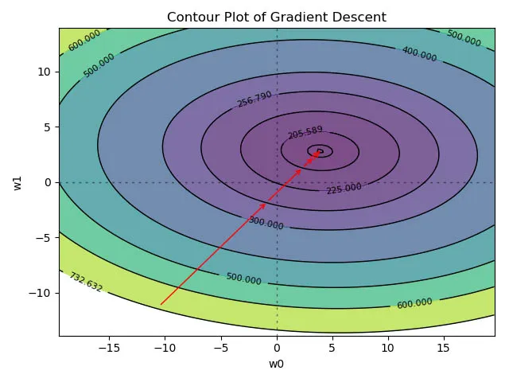
    - Experiment with different learning rates while updating the theta values and analyze how the contour plot changes.
    - Use a python library (such as sklearn) to perform all these tasks.
    - Use the User database and predict whether a user will purchase the company’s newly launched product or not.
    - Predict the profit values on the 50_startups dataset for each company.

